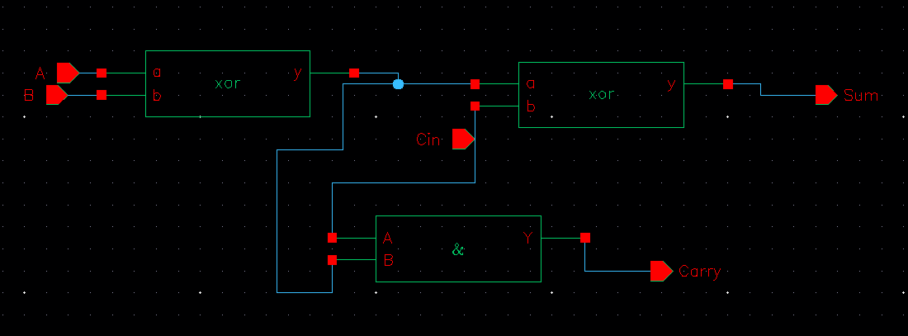
Approximate full adder
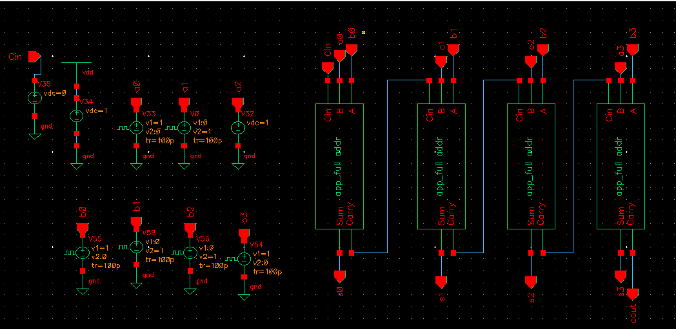
Approximate 4 bit adder
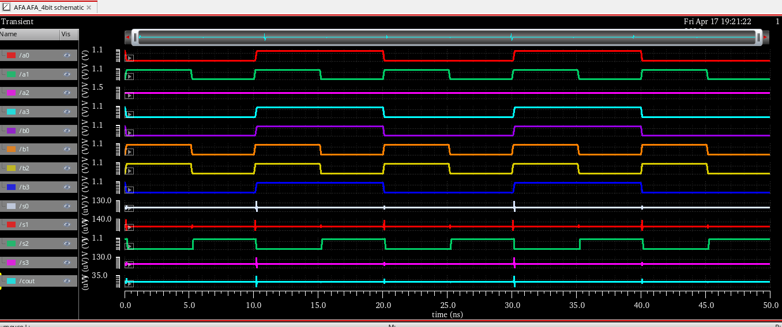
Waveform of Approximate full adder 4 bit
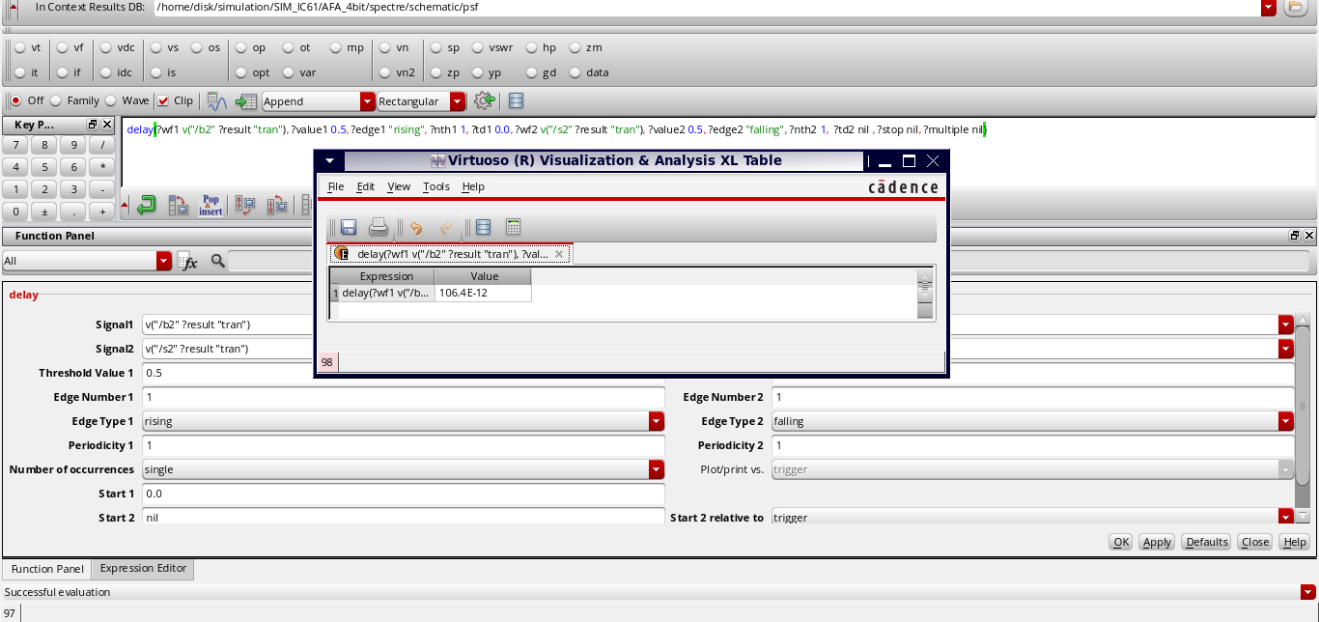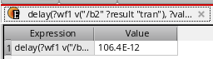
DELAY VALUE OF AFA 4 BIT
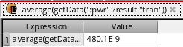
Power consumption of AFA 4 bit
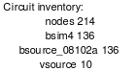
Mos count of AFA 4 bit

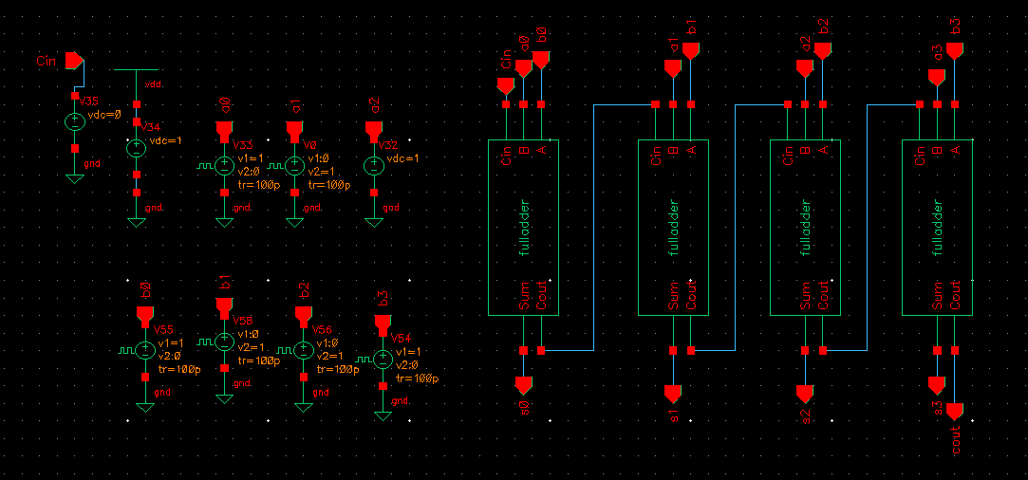
4 bit rca
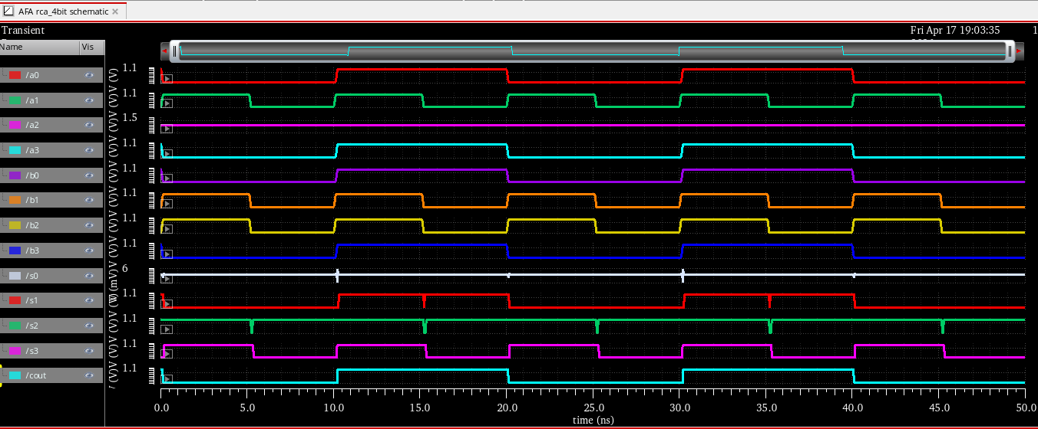
Waveform of 4bit rca
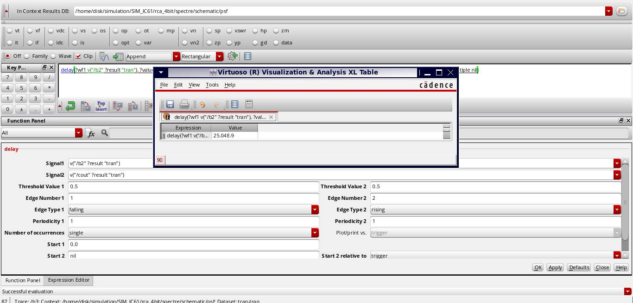
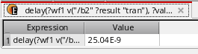
Delay value of 4bit RCA
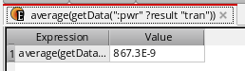
Power consumption of 4bit RCA
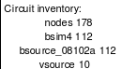
MOS COUNT OF 4 BIT RCA

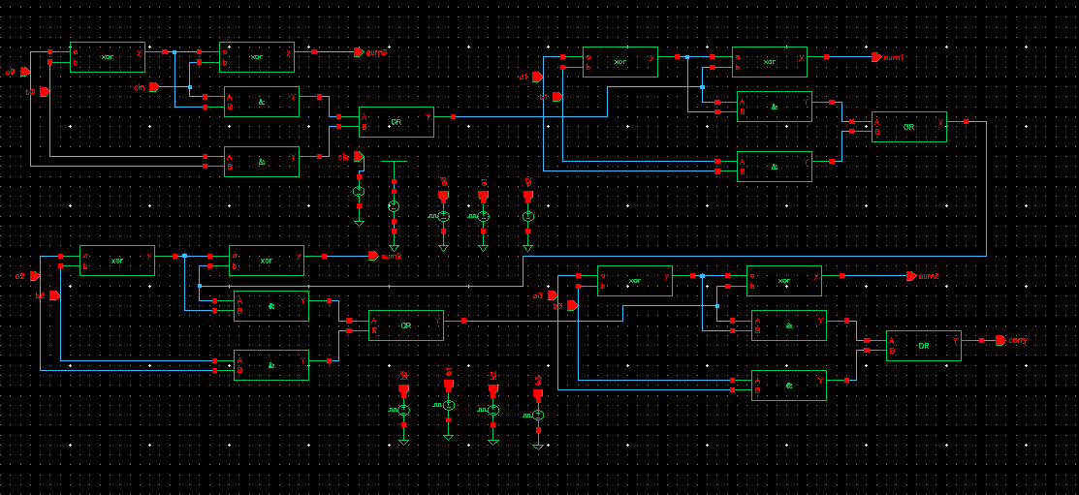
4 bit cla
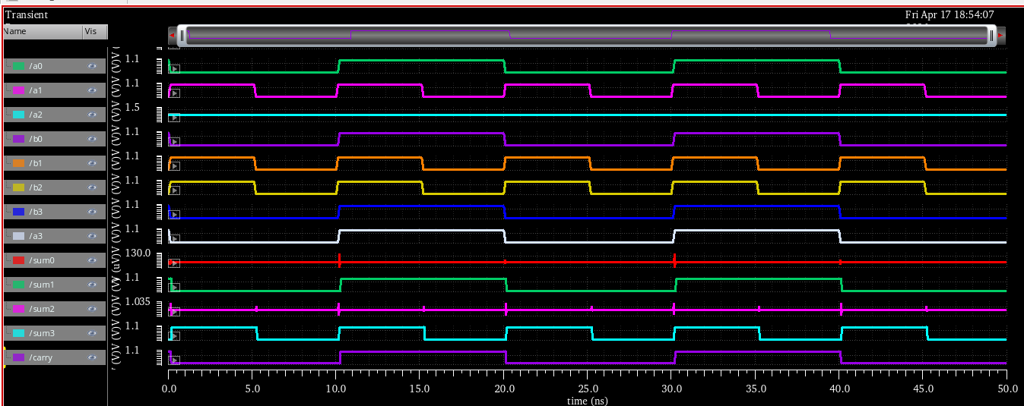
Waveform of 4 bit cla
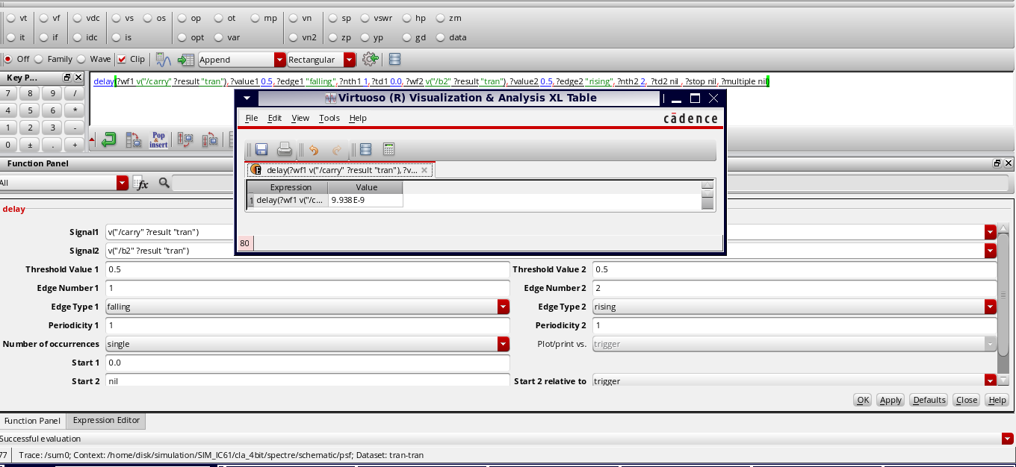
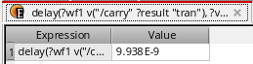
DELAY FOR 4BIT CLA
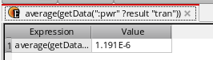
Power consumption of 4bit cla
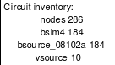
Transistors count of cla 4 bit
 | Mos count | Power consumption (nW) | Delay (ns) | PDP (aj)
Appr_adder | 136 | 480 | 0.1 | 48
RCA | 112 | 867 | 25 | 21675
CLA | 184 | 1191 | 9 | 10719

